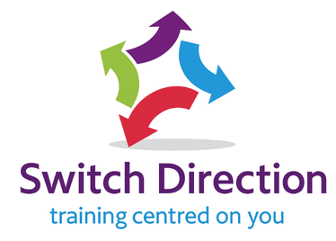
SKILL FRAMEWORK
Starter Template

A free tool to help you turn training from random to strategic
Why bother with a framework?
This template gives you a straightforward way to build your own framework, role by role. No jargon, no consultancy price tag — just a clear structure you can adapt.
How to use this template
1. List the roles in your business — Start with the roles that matter most right now — you can always add more later.
2. Pick 5–6 skills per role — Choose the skills that genuinely separate an average performer from a strong one. Fewer, sharper skills beat a long vague list.
3. Set the required proficiency level — Use the 1–4 scale below to say how good someone needs to be in that skill for the role.
4. Score where people are today — Be honest. This is the gap that training should close — nothing more, nothing less.
5. Turn each gap into an action — One clear next step per gap: a course, a mentor, shadowing, or on-the-job practice.
The proficiency scale
Use this as your starting point — adjust the wording so it fits how your business talks.
Level | Label | What it looks like
1 | Aware | Understands the basics but needs close support and guidance to apply the skill.
2 | Developing | Can apply the skill in routine situations, but needs help with anything unusual or complex.
3 | Confident | Applies the skill reliably and independently across most situations the role involves.
4 | Expert | Applies the skill with judgement even in complex or unfamiliar situations and can coach others in it.
Worked example
Here is what a completed row looks like for a Customer Service Advisor role:
Skill | Required level | Current level | Gap | Action
Objection handling | 3 | 2 | 1 | Role-play coaching, three sessions
Now build your own — use the blank grid below (or recreate it in a spreadsheet if you are covering several roles at once).
Your framework: blank template

Role: _______________________________________________

Skill | Required level | Current level | Gap | Action

Want help building this out properly?
Switch Direction works with businesses to build full skill frameworks, spot the real gaps, and design training that earns its budget.
training centred on you

